A project assessing the views of post-primary teachers regarding the Northern Ireland Revised Curriculum and its’ effect on the teaching of Modern Languages
This project seeks to assess the views of post-primary school teachers regarding the Northern Ireland Revised Curriculum (RC) and how the changes associated with it will affect the teaching of modern languages in schools.

Section 1
This first section analyses the sample itself in terms of what type of school the teachers work in, their position within their respective schools and which languages are taught at each school at KS3. Two closed questions which were included in the survey are then analysed to assess the following; whether teachers feel the position of ML’s will be strengthened, weakened or unchanged by the RC and whether the schools provision for ML’s at KS3 has changed as a result of the RC.
As chart 1 below illustrates, the overall sample consisted of 27 post-primary school teachers across Northern Ireland; 14 secondary school teachers and 13 grammar school teachers. Therefore the sample is almost equal in terms of representation for secondary schools and grammar schools.

Chart 1
The overall sample of teachers in relation to which type of post-primary school they represent

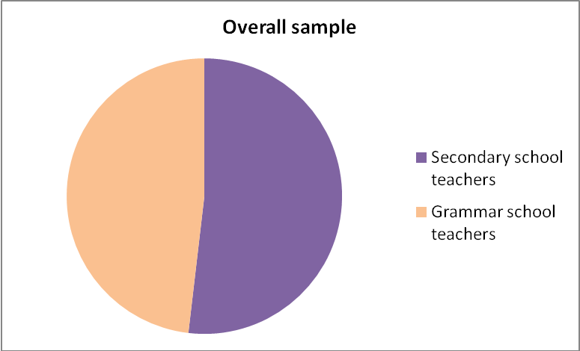

Tables 1 and 2 below illustrate each teacher’s position within their school regarding Modern Languages. As the tables show, most of the teachers who took part in the study, from both types of school, are Heads of Departments, (HOD’s) although some also have additional roles within the school such as Head of Languages, Language Co-ordinator, Class teacher or Year Head. Only 4 of the 27 teachers involved in this study are not HOD’S, therefore 85% of the sample are Heads Of Departments in their schools. To differentiate between secondary school teachers and grammar school teachers, each teacher who took part in the research was labelled R (respondent), followed by either an S (secondary) or a G (grammar), and then followed by a number. Therefore ensuring it is possible to identify which type of post-primary school they currently teach at.

Table1
Position of each teacher within the secondary schools which took part in the study
Respondent number | Head of Department | Head of  Language | Class  Teacher | Other  position
RS1
RS2
RS3
RS4
RS5
RS6
RS7
RS8
RS9
RS10
RS11
RS12 |  |  |  | Head of KS3
RS13
RS14

Table2
Position of each teacher within the grammar schools which took part in the study
Respondent number | Head of Department | Head of  Language | Class  Teacher | Other  position
RG1
RG2
RG3
RG4
RG5
RG6
RG7
RG8 |  |  |  | Co-ordinator of ML
RG9
RG10
RG11
RG12
RG13

Languages taught in the respondents schools at KS3 level
The following three charts illustrate which languages are taught in each of the respondents’ schools at KS3 level. The results show that French is the most popular language in both types of schools; 100% of both types of schools surveyed offer it at KS3. It can however be concluded that there are substantially more languages offered in the grammar schools in question, than there are in secondary schools, at KS3 level. 85% of the grammar schools surveyed offer Spanish at KS3, while only 50% of the secondary schools do so. The situation regarding German is even more polarised, with only 14% of secondary schools teaching it at KS3, in comparison with 77% of grammar schools. The statistics are significantly different for Irish as the levels of Irish teaching are relatively similar in both types of school; 50% of secondary schools teach this language at KS3, while 54% of grammar schools do so.

Chart 2
Languages taught at KS3 in secondary schools

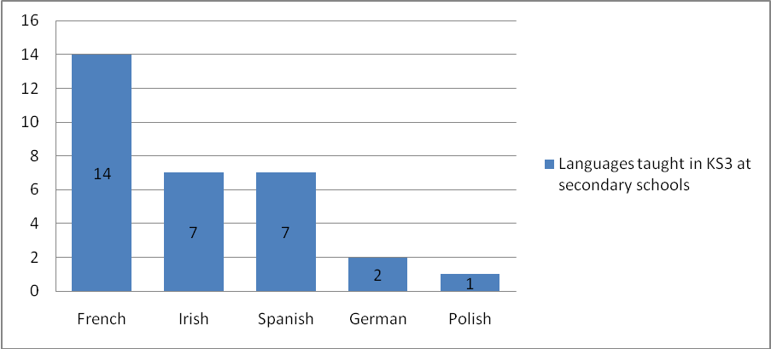

Chart 3
Languages taught at KS3 in grammar schools

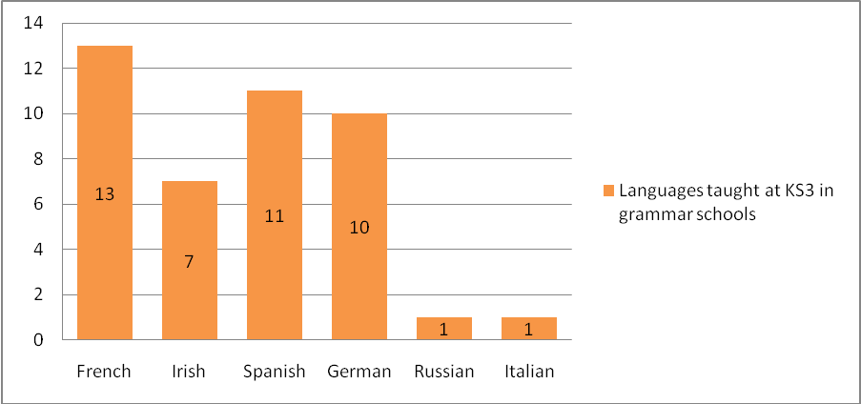

Chart 4 below illustrates which languages are taught at the respondents’ respective schools at KS3 level to enable comparison. The chart highlights the prevalence of language learning in both types of school and shows that more languages are clearly being taught in the grammar schools in question at KS3 level.

Chart 4
Languages taught overall at KS3

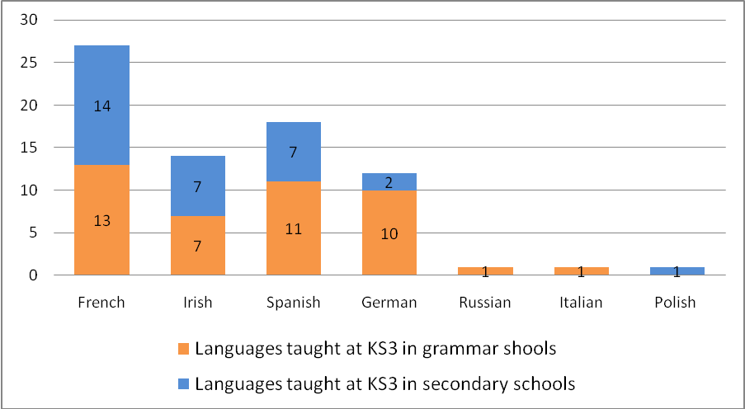

Change in the position of ML’s due to the RC
Charts 5 and 6 below shows the results of how teachers feel regarding the effect of the RC on the position of Modern Languages. As the charts show not 1 teacher felt the position of languages would be strengthened by the RC. Overall 16 felt it would be weakened; 7 grammar school teachers and 9 secondary school teachers. While 11 of the teachers questioned felt the position of ML’s would remain unchanged; 6 grammar school teachers and 5 secondary school teachers. Clearly there is strong feeling among teachers that the RC will weaken the position of ML’s as almost 60% of teachers felt this way. Just over 40% of the sample felt the position of ML’s would not change, while 0% of the teachers questioned believed it would be strengthened.

Chart 5

Teachers views on how the position of Modern Languages will be effected by the Revised Northern Ireland Curriculum

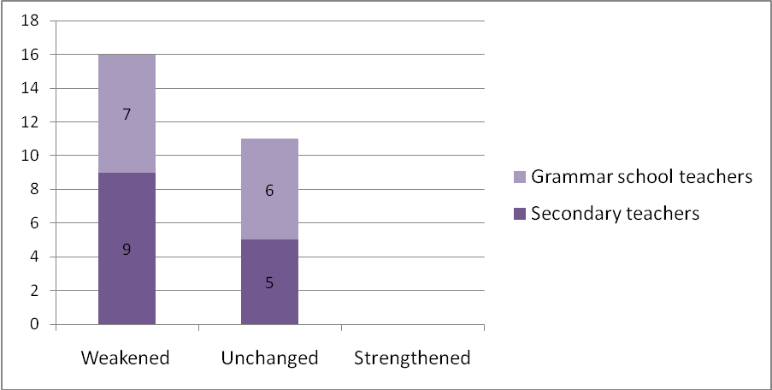

Chart 6
Overall teachers views on how the position of Modern Languages will be effected by the RC

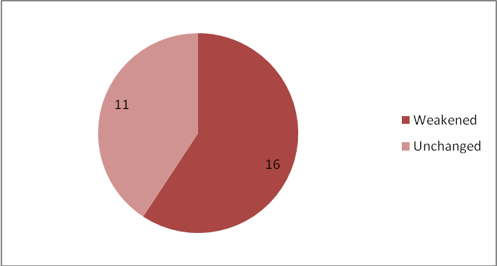
School’s provision for Modern Languages at KS3
Chart 7 below illustrates the views of teachers regarding whether there has been any changes in their schools provision for Modern Languages at KS3 as a result of the RC. As the chart clearly indicates less teachers state that there has been a change in their schools’ provision for ML’s at KS3; approximately 40%, than state that there has been no change; approximately 60%. Also it is noteworthy that extremely similar proportions of secondary school teachers and grammar school teachers report changes in the provision for ML’s at KS3 in their school; 5 grammar school teachers and 6 secondary teachers. In addition, the numbers of those who report no change has occurred in both types of school are exactly equal; 8 teachers from each type of school report this.

Chart 7
Teachers views on whether there has been any change in the school’s provision for ML’s at KS3

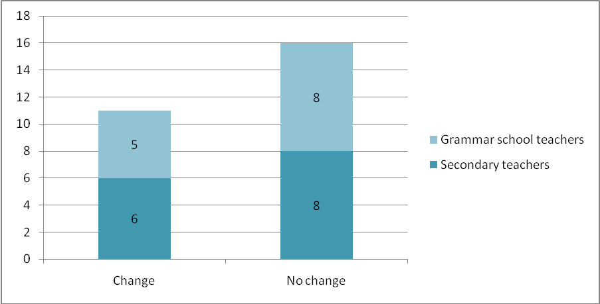

Section 2
Qualitative data collected by the study
This section analyses the qualitative data collected by this project, specifically the teachers’ comments regarding their views regarding Northern Irelands’ Revised Curriculum (RC). The data was initially transcribed verbatim in order to obtain an in-depth awareness of the precise information provided by the respondents. The data was then open coded in order to categorise the information into distinct areas. These codes then acted as potential indicators of particular themes which emerged from the data during this process. As previously stated, to differentiate between secondary school teachers and grammar school teachers, each teacher who took part in the research was labelled R (respondent), followed by either an S (secondary) or a G (grammar), and then followed by a number. Therefore ensuring it is possible to identify which type of post-primary school they currently teach at. The questions which yielded these comments were relatively open-ended and are listed below in table 3.

Table 3
Questions asked in the questionnaire administered to post-primary school teachers
Q1 | In your opinion will the Revised Northern Ireland Curriculum result in the position of modern languages being strengthened, weakened or left unchanged? Give reasons.
Q2 | What do you consider to be the advantages and improvements for Modern Languages in the Revised Curriculum?
Q3 | What do you consider to be the disadvantages or drawbacks for Modern Languages in the Revised Curriculum?
Q4 | Have you any general comments on the Revised Curriculum?
Q5 | What training has your department received for the Revised Curriculum?
Q6 | How adequate do you consider training to have been for Modern Languages?
Q7 | How adequate does your department consider training to be for individual languages?
Q8 | Do you consider the position of all the languages offered in your school to be secure? Please comment on each language your school offers.
Q9 | Has there been any change in the school’s provision for Modern Languages at KS3 since the introduction of the Revised Curriculum? Comment.
Themes
Twenty key themes emerged from the data collected; these are listed below and subsequently discussed in more detail.

- Many elements of the RC were already being implemented
- The position of ML’s is weakening and is under threat as they are optional
- Teachers are still adjusting to the RC and more time is needed to assess its effectiveness
- There is less contact time available under the RC
- Other subjects are being given priority over modern languages
- Grammar and vocabulary are neglected by the RC and less content is included
- The RC involves excessive paperwork and preparation
- There are major concerns regarding the future of modern languages
- Some teachers feel undermined, disillusioned or fatigued
- The RC is based on ‘topics’ much more so than the previous curriculum
- The RC is more skills based
- There is an increased focus on ICT and multimedia methods
- The RC encourages independence among students
- The RC encourages active learning
- The RC can increase collaboration between ML’s and other subjects
- The RC can increase teacher autonomy
- Languages are perceived as a difficult option
- The RC affects those of different ability unequally
- Less Target Language is used in the classroom under the RC
- Classes are more unsettled due to the RC’s teaching methods

The above themes are based upon the views expressed by the teachers who took part in the survey and to support these themes a collection of quotes are listed below the discussion of each one.

- Many elements of the RC were already being implemented
Six of the secondary school teachers and six of the grammar school teachers who took part in the study felt that many elements of the Revised Curriculum were already being implemented and that it did not contain many revolutionary ideas. Almost half of the overall sample expressed the view that the RC is not entirely new and equal numbers of teachers from both types of school felt this way. One teacher described it as ‘repackaging’ while others felt Modern Language learning was always ‘active’.
This theme that the RC did not consist of entirely new ideas ran throughout much of the data collected. Some teachers expressed the view that the RC will not change much in reality. The quotes below show that several teachers feel that the RC is somewhat a formalisation of what was already being carried out in classrooms and that many of its’ features were being practiced prior to its introduction.

RS1: “much of what is highlighted as a focus in the RC, I would have included [in my teaching] anyway”.
RS2: “Language learning was always active learning and covered many aspects of [the] Revised Curriculum”.
RS3: “Modern Languages have always been using active learning”.
RS8: “The teaching approaches i.e. group work and developing of skills is nothing new to what we are already doing”.
RS11: “I feel new terminology is being used for activities already happening in the modern languages classroom e.g. key elements in place of cross curricular themes”.
RS14: “I don’t see anything too revolutionary here, especially when we teachers still strive to produce good exam results”.

RG5: “Teaching has not changed greatly, nor teaching methods [under the RC]” ... “I feel many elements were already embedded in modern language teaching – thinking skills, making connections etc”.
RG6: “A massive exercise in repackaging which will make very little difference to what actually happens in the classroom ... [One advantage is] recognition that we are ahead of the game”.
RG8: “Active teaching and learning has always been part of language learning anyway and as a result language teachers were at an advantage”.
RG9: “Much of what we were already doing has been reinforced”
RG10: “Most language classes already incorporate many of the ‘new’ ideas”.
RG13: “As regards teaching methods the revised curriculum makes no difference as ML teaching has always been lively and active!”

- The position of Modern Languages is under threat
The sentiment that modern languages are under threat was echoed among many of the teachers questioned. It was felt by some that there is now less emphasis on languages in schools than there previously was and that the learning of languages is not viewed as a priority by schools or pupils. Others felt that languages are losing popularity and that more and more languages are being dropped by school management. In addition it was felt by some that the RC neglects modern languages and that they are losing their place in the curriculum. The quotes below outline the concerns some teachers have regarding the weakened position of languages and the loss of popularity they are experiencing.

RS4: “Cross Curricular skill - we are at a huge disadvantage – no place for MFL”
RS9: “People don’t realise the importance of languages, both senior management and pupils”.
RS10: “The position of Modern Languages depends on a schools view of ‘what is our priority’. Until that changes, Modern Languages will not be promoted at whole school/management level”
RS12: “Languages are being forced out of Senior School”.
RS14: “Our school, starting September 2009, has dropped French, one of the 3 ML’s already taught”.

RG4: “French and Spanish in particular seem to be losing their popularity ... I am worried that fewer and fewer boys are opting for languages at year 11 and I feel that this is simply because they have concluded that there is no need to study languages”.
RG6: “The position of ML’s is more under threat now than ever in my 25 years in teaching”.
RG10: “German has been dropped”.
RG12: “As far as languages are concerned, we have now lost a lot of ground and generally feel very disheartened” ... “Because of a drop in their [ML’s] importance, we have lost a lot of our past prestige” ... “If this tendency continues we might lose our double linguists”.

In addition, two secondary school teachers and two grammar school teachers pointed out that ML’s are now more optional than in previous years and therefore are at a distinct disadvantage. As a result, the general concern is that fewer students will choose to study languages and due to this lack of demand there may be less language learning undertaken in schools in the future.

RS2: [ML’s are] “made an option subject at the end of KS3”.
RS3: “Now that they are optional, not as many students will choose to study a language”
RG4: “The greatest threat facing all the languages is the optionality of language study in year 11”
RG8: “Languages are no longer compulsory and, as a result, numbers could be affected”

One secondary teacher and one grammar school teacher added that reduced support for modern languages was another result of the Revised Curriculum. They felt that there is less provision and support for languages than there previously was and that this has left languages under threat.

RS4: “Less provision” [for ML’s under the RC – noted as a disadvantage].
RG6: “Lack of subject support from Government, either in UK or NI” ... “MFL has slipped so far down the agenda, we feel that it has been abandoned, despite moves in the Primary Sector. The economic challenges of the next few years will only exacerbate the problem”.

- More time is needed to assess and to adjust to the RC
Several teachers made comments that implied that they are currently waiting to see how the Revised Curriculum will work over time before judging its effectiveness. There was a feeling that more changes are still necessary and that more time is needed to allow teachers and pupils to adjust to the new curriculum. The quotes below from two secondary school teachers and one grammar school teacher show that there is a feeling that more time is needed for teachers to adjust to the RC.

RS10: “Teachers need time to develop resources to be able to teach the revised curriculum”.
RS11: “gradual steps and changes need to be made”.

RG1: “It is working well but needs to be embraced more by everyone”.

In addition it was felt by some that teachers need more confidence in relation to delivering the RC. Two of the secondary school teachers involved in the research felt that there exists a lack of confidence among teachers regarding teaching the Revised Curriculum and that this needs to be addressed.

RS11: [There is a] “lack of confidence on teachers’ part introducing active learning methods”
RS9: “Most people are still not sure/entirely confident about delivering it fully”

- There is less contact time available
The fact that teachers now have less contact time with language students was mentioned by four of the secondary school teachers and six of the grammar school teachers. This represents over a third of the entire sample of respondents. There was a clear feeling that language teachers felt their subjects were being ‘squeezed’ out of the timetable, with less and less teaching time available to them. The following quotes highlight how strongly many teachers feel about this reduction in contact time.

RS1: “Our teaching time has been eroded to a mere three lessons (30 minutes each) per week”.
RS2: “Reduced time allocation for year 9 and 10 middle bands”.
RS6: “Because of demands on the school timetable there is the possibility of contact time for MFL’s being reduced”.
RS7: “[There] seems to be less time for languages” ... “Reduced timetable time”.

RG1: “Lesson time is very short” ... “Yes [there has been changes], less time for languages – 3 x 35 minutes per week in Year 9 and 10. 4 x 35 minutes in year 8”.
RG2: “Less teaching time for languages in forms 1-3”.
RG3: “The revised curriculum is ‘squashing’ our timetable somewhat”.
RG6: “As ever, we are struggling to find time at KS3”.
RG10: “French [has been] cut from 5 to 3 periods in years 9 and 10”.
RG12: “We are losing teaching time”.

- Other subjects are a threat to Modern Language’s
Almost half of the teachers feel that citizenship, media and other subjects are sometimes given more priority than languages and/or that they appear more attractive to students. Some also felt there was too much competition from other subjects and/or that modern languages are not promoted well to pupils. Many also stated that other subjects are being given more priority than Modern Languages are resulting in less time being devoted to the learning of languages.
The quotes below show that thirteen teachers, seven grammar school teachers and six secondary school teachers, expressed the belief that other subjects are endangering the future of modern language teaching.

RS2: “Time allocation reduced because of other subjects being included” ... “Other subjects are being added and given more importance”
RS6: With more vocational options, less pupils are choosing languages”
RS7: “Seems to be less time for languages with other subjects being incorporated into curriculum”
RS12: “Pupils [are] actively encouraged to choose Business Studies, BCS, Media as these are main elements at A level. Very worrying!”
RS13: “Placement [of languages] in option groups set against ‘sports studies’ and music where numbers are limited” (noted as a disadvantage)
RS14: “The introduction of new subjects e.g. citizenship and other aspects of Learning for Life and that tends to impact more on modern languages than other subjects” ... “The emphasis on Learning for Life and Work is detrimental for other subjects”.

RG1: “More subjects which are “compulsory” therefore less space for MFL”.
RG2: “The increase in the number of subjects being taught” (noted as a disadvantage)
RG3: “Some pupils in year 9 have dropped their second language (German/Spanish/Italian) to have extra literacy and numeracy classes”.
RG6: “Because of the proliferation of other statutory subjects, like LLW and traditional preserves”.
RG10: “We have already been forced to drop German at KS3 in order to timetable citizenship, LLW etc”.
RG12: “Our allocation of periods has decreased to allow for employability and citizenship”.
RG13: “Other subjects and initiatives and projects are squeezing ML further and further out of the curriculum”.

- There is less content under the RC and grammar is neglected
Four of the secondary school teachers and four of the grammar school teachers noted the reduction of grammar and vocabulary in the Revised Curriculum as a concern and as one of the RC’s flaws. Many felt that this change in policy is a mistake expressing strong concern about the lack of content. One teacher added that the idea of less content does not coincide with the exams which pupils will be taking. The quotes below show that there is clear concern among some teachers that content will not be covered to the degree that it should be and that this may weaken the teaching of languages further.

RS1: “Having been told in the official training to teach less content, more skills, we are automatically weakened”.
RS4: “Concerns for lack of content”.
RS10: “less content may mean more ‘rushed’ topics in KS4”.
RS11: “Content may be reduced” ... “will content be covered?”.

RG2: “Watered down content” (cited as a disadvantage of the RC).
RG3: “ALSO – GCSE/AS and A level exams don’t correspond to idea of less content”.
RG4: “If skills and capabilities ignore content (syntax/vocabulary/grammar/intonation/pronunciation, etc) then that is a mistake in my opinion” .
RG5: “[There is] fear that there will be less focus on grammar skills”

One grammar school teacher noted that content cannot be neglected regardless of the RC.

RG9: “We still teach content, as a language can’t be learned without knowing the vocabulary, grammar etc.” ... “I still teach grammar as I believe this is important. Therefore it’s not all ‘jumping around’!”.

However some teachers feel that this reduction of content is of benefit to students as it may result in language learning being more enjoyable or may be helpful for those in younger age groups.

RS6: “Reduced content at KS3 gives more opportunity to engage pupils more in pupil-centred activities”.
RG3: “Less focus on content for younger classes” (notes this as an advantage).
RG7: “Content reduced, students enjoy active learning strategies”

- Excessive paperwork and preparation
Six secondary school teachers and two grammar school teachers felt that the new curriculum is overly demanding on teachers in terms of paperwork, preparation, time or administration. There was a sense among teachers that this extra paperwork involved was a waste of time and that it only distracts and diverts teachers from their main role. It was also suggested that there is excessive pressure on teachers and that they are expected to do too much in the time available. The quotes below highlight that several teachers feel overwhelmed by the workload prescribed by the RC.

RS1: “It is impossible to quantify the time and energy that RC has drained from our teaching and our lives” ... “Perhaps other schools create gaps in time and space but we seem fairly hard pressed” ... [collaboration with other departments] requires so much preparation that it only happens infrequently” ... “We have no time to reflect, experiment, try to be creative in dealing with it all”.
RS5: “We do not usually deliver as much as is now required”
RS10: “Not enough time to prepare”.
RS11: “A lot of paper work involved – revising schemes of work”.
RS12: “Too much time taken up with Learning Intentions and Success Criteria and the administration which goes along with this” ... “ [I] don’t like all the administration!”.
RS14: “not easy to develop [pupils skills] while being under pressure to produce good exam results.

RG1: “Skills approach takes more time to deliver” ... “New curriculum demands and revision of timetabling, schools have not changed accordingly in all areas to allow for this” ... “There is a lot to cope with and little time ... to discuss and plan” ... “We need more time to evaluate and include MER across all sectors”,
RG13: “More activities to prepare ... more work for teachers”.

- Concern for results and the future
Four secondary school teachers and one grammar school teacher expressed concern regarding the academic future of modern languages. These concerns relate to future student exam results and the knowledge gaps which may appear between KS3 and KS4. The quotes below highlight these concerns held by some teachers.

RS4: “Big concern – for gap between KS3 and KS4” ... “Concerns for ... effect on exam results”.
RS6: “[It] May be more difficult to achieve a good grade at GCSE”.
RS9: “It will widen the gap in knowledge required between KS3 and 4”.
RS11: “will pupils be prepared adequately for GCSE level? “.

RG11: “Considering that the content of the new curriculum (TS, PC etc) is so concerned with what seemed like mere good manners and very basic communication skills I wonder where our top class graduates will come from in future years?”.

- Teachers feel undermined, disillusioned or fatigued
The data collected revealed that one secondary school teacher strongly felt that they were being blamed for the weaknesses within education and that this has seriously affected their confidence.

RS1: “I do not appreciate being made to feel that what I have been doing for almost 28 years has been under par or inadequate” ... “My confidence does NOT need this at this stage ... RC has done more to knock our confidence than anything I remember in my career”. “It seems to point the ‘blame’ for weakness in education at teachers, who strive against odds stacked up against them to do a good job ... it remains one of life’s mysteries whether we are getting it right or not”.

Other teachers expressed feelings of disillusionment and/or fatigue regarding the RC.

RG6: “A depressing time to be a teacher of MFL. The Revised GCSE and A level courses are not inspiring, [but are] the reverse!”
RS5: “Yet another new initiative”

- ‘Topics’ based approach
There was a feeling among some teachers that the new topic/theme based approach to language teaching under the RC may not be beneficial. One secondary teacher felt the topics based approach is too contrived and another argued that it is not a helpful approach to language learning in reality, for example, in the target language country. One grammar school teacher agreed and pointed out that vocabulary is not always transferable and therefore still needs to be learned.

RS8: “By concentrating solely on themes, I feel that we are denying pupils access to many areas which would be important if they were to visit the target country”.
RS13: “Concerns re: ‘contrived topics’ e.g ‘Ireland in the past’ to facilitate ‘links’ across the curriculum and concerns re: ‘sourcing’ of information by pupils” ... “contrived links and artificial content not allowing for limitations in language skills and taking away from a progressive grammatical approach”.

RG10: “Whilst a move from knowledge based to skills based learning seems like a good idea, learning certain vocabulary will not transfer to another area (e.g. learning about food will not help you buy a train ticket)” ... “Knowledge of vocabulary will still require learning”.

Despite the above comments, other teachers felt that the themed approach contributes to language learning as it is pupil friendly.

RS3: “Schemes are now very pupil-friendly” ... “The specs are written with the 21st century in mind. Pupils enjoy what they learn and they can relate it to everyday use”.
RS12: “Themed Units also work well – doing healthy eating at the moment. Pupils seem to like this”.

- The RC is highly ‘skills’ based
Four secondary school teachers made the point that actual language learning is being sidetracked in order to teach other skills and to follow the RC closely. However three grammar school teachers felt that the skills-based approach is beneficial and is a welcome development in language teaching. It is interesting to note the divide here between teachers views in either type of post-primary school.

RS1: “[Regarding the Christmas exam] “We ... spent time teaching skills which we cannot assess in a written exam”.
RS6: “More time is devoted to developing other skills rather than specific language skills”.
RS14: “Too much emphasis on things other than the subject” ... “The theory of pupils developing skills in order to [achieve] more effective relevant study is laudable”

RG1: “Pupils do benefit [from the skills based approach] and are more confident”.
RG3: “Advantage – focus on skills. This is something we’ve been trying to communicate for years!”
RG4: “I think that an emphasis on skills and capabilities is welcome”

- Increased focus on ICT and multimedia methods
Several teachers pointed out that one significant difference between the former curriculum and the revised curriculum was the increased focus on ICT and multimedia methods. Four teachers cited increased ICT and multimedia use as beneficial, while one mentioned the ability to develop PC and TS as an advantage of the RC. There was a feeling that the increased focus on TS was advantageous and one secondary school teacher mentioned AFL as a suitable method of learning languages.

RS1: “[ICT] is a motivating factor in that pupils love to engage with a screen” ... “focus on TS is positive”.
RS5: “AFL lends itself to languages”

RG1: “Greater use of ICT has benefits, as do multimedia for presentations etc”
RG8: [The RC is an] “excellent platform to develop TS and PC”
RG9: “I personally have started to use ICT as an integral part of teaching” (viewed as an advantage of the RC)

However not all teachers viewed the increased use of ICT as a positive development. One secondary school teacher felt that the RC would lead to less creativity among ML students due to the increased emphasis on ICT regarding language learning.

RS1: “Focus on ICT only reinforces the reluctance to think creatively” ... “focus on ICT works against creative thinking in general”

- More student responsibility and independence
Independent learning was cited as a benefit by four secondary school teachers and two grammar school teachers, all of whom believe the RC encourages self assessment, independent learning and that it helps students ‘think for themselves’.

RS2: “Pupils more aware of the learning intentions”.
RS3: “Now with assessment for learning they are benefiting even more”.
RS11: “Pupils are taking more responsibility for their own learning in assessing themselves using a range of ways e.g. learning intentions, peer/self assessment”.
RS12: “Good, because children are encouraged to think for themselves” ... “more thinking, self/peer evaluation” ... “an emphasis on the pupils to take control of their own learning”.

RG1: [Pupils] “use independent skills” (cites this as an advantage of the RC).
RG5: [The RC will be beneficial if it] “involves pupils in [their] own learning”.

- The RC encourages more ‘active’ learning
Two secondary school teachers and four grammar school teachers stated that one advantage of the RC was that the teaching approach is more active. This is, they feel, an effective method of teaching languages to pupils of post primary age. Several teachers expressed approval of the new methodology which is employed under the RC which includes more interactive learning, group work, and less ‘chalk and talk’ methods resulting in the RC being more ‘engaging’, according to some teachers.

RS11: “Through time learning experiences will be enhanced through active learning methods”
RS10: “The greatest improvement in language provision is in relation to methodology – active learning works”
RG1: “Pupils are more active” (cited as an advantage)
RG5: “If it encourages teachers to be less ‘chalk and talk’ [and to be] more interactive in classroom.
RG9: “A lot more group work” ... “more active learning” (cited as advantages of the RC).
RG10: “Pupils may become more actively involved in learning the language”

- Collaboration with other subjects
Some teachers felt that the RC allows more connected learning to occur in terms of cross-curricular collaboration between different subject areas. Three secondary school teachers and three grammar school teachers cited collaboration with other subjects as one benefit of the Revised Curriculum. It seems that teachers view this as a benefit as it reduces the isolation felt by some language teachers. The quotes below show that several teachers view collaboration with other subjects as a positive feature of the RC.

RS1: [One benefit is] “possibly the potential for collaboration with other departments e.g.History etc”
RS4: “We are a communication based subject so we have strengths in that area, working with others”.
RS11: “Collaboration with other departments i.e. assessing the cross curricular skills” [cited as a benefit of the RC].

RG4: “I think, in general, that the creation of links between subject areas is positive” ... “It is too easy to be isolated from other subjects and I think that linking learning will benefit students”.
RG5: “Cross-curricular work could be very beneficial”.
RG8: [The RC provides an] “excellent opportunity for cross-curricular links i.e. connected learning” ... “we [ML teachers] also can contribute to many other key areas e.g. citizenship, drama”.

- More teacher autonomy and input
There is less emphasis on textbooks under the RC, according to many of the teachers in the sample. As a result it was mentioned several times that teachers have more freedom and flexibility in the classroom. The quotes below show that one of the grammar school teachers and four of the secondary school teachers felt that one benefit of the RC was that teachers have more autonomy.

RS5: “Teachers able to have a greater input into the curriculum content”.
RS7: “More flexibility” (cited as a benefit of the RC)
RS9: “More opportunity/scope to tailor classes to needs of pupils”.
RS14: “More teacher autonomy is welcome”.

RG2: “Greater freedom to move away from text books”

However one grammar school teacher stated that, although the RC appears to be allowing teachers to be more flexible, they believe this is not the case in reality.

RG13: “It would be good if it did give schools/teachers more freedom to teach as, and what, they wish to teach. In reality, this is not the case” ... “schools are over-regulated in every respect”

- Languages are perceived as a difficult option
It was noted by two teachers in the sample that there is a perception among some students that modern languages are more difficult to do well in than other subjects and that this is contributing to the poor uptake of languages. The quotes below, one from a secondary school teacher and one from a grammar school teacher, illustrate that there is a perception among students that ML’s are a difficult option.

RS3: “Languages are always seen as a ‘difficult’ GCSE”.

RG6: [ML’s are under threat] due to perceived and real difficulties with ML’s at both GCSE and A level” ... [ML’s are] “still a hard option”.

- Ability range differences
One secondary school teacher and one grammar school teacher noted that they felt the RC was focused on very basic achievement and that this would be detrimental to students who were ambitious or of high ability regarding languages. However, the same secondary school teacher also expressed the view that the RC does enable weaker students to learn languages more effectively.

RS8: “It does not push the able learner” ... “Many of the topics covered in the National Curriculum will be diluted to provide a very basic grasp of language and grammar” ... “I feel that the Revised Curriculum is good for weak learners”.

RG11: “There will be little to stretch the ambitious in the new curriculum” ... “’Dumbing down’. Hyperbolic descriptions of very basic levels of achievement. Insufficient rigour”.

- Less target language used
One secondary school teacher and two grammar school teachers cited the fact that less target language (TL) is used in the classroom under the RC as detrimental. They state that this lack of the use of TL is a disadvantage of the RC and that it weakens language learning.

RS12: “Not as much target language being used [and the] overall language experience is weakened as a result”.

RG6: “Disadvantages – reduction in use of Target Language” because of Learning Intentions and negotiating Success Criteria in English ... Same applies to Thinking Skills tasks and contributing to assessment of ICT”
RG8: “Requirement to discuss and evaluate learning needs to be carried out in MT, not TL” [which is a disadvantage according to RG8].

- Unsettled classes
One secondary school teacher and one grammar school teacher argued that the RC could result in class time becoming more unsettled as they believe students might expect to be ‘entertained’ by teachers.

RS11: “Classroom management may become an issue”

RG13: “Classes may become more unsettled and used to ‘being entertained’”.

Section 3
Training provided
This section assesses the training provided regarding the introduction of the RC and the adequacy of this training. Training is reported to have been provided by a range of different providers such as various Education and Library Boards, CASS, INSET, SDD, and the CCEA. Several teachers mentioned the fact that not enough training was provided while others felt the training on offer was unsuitable. Below are the responses to the question;
“What training has your department received for the Revised Curriculum”?

RS1: “Training provided by SELB and CASS” ... “The main problem is that training is sandwiched between full teaching timetable days”.
RS2: “In-service and board training”
RS3: “In service on cross curriculum skills, thinking skills and personal capabilities and active learning”.
RS4: “Several whole days and in school whole staff support” ... “none for department only”
RS5: “AFL. Questioning. Writing units of work”.
RS6: “2 general training days for all staff” ... “1 language specific day at board centre with another school”. “HOD training”
RS7: “Various INSET days both inside school and at board”
RS8: “We have had meetings in school which have been based around the Revised Curriculum”
RS9: “A few inset training days in school and one area meeting”
RS10: “A few days ... but mostly in department”
RS11: “Two training days provided by the SEELB”.
RS12: “Quite a bit” ... “Enjoyed days out with other schools. I am the only language teacher so it’s nice to mix with other linguists”
RS13: “In-school training – language specific (Ulidea)”.
RS14: ----

RG1: “Board support mainly and some inset through SDD” ...“time has been less this year than in [previous] years, impetus has waned”
RG2: “Staff training days as a department, as a school, and for individual languages”
RG3: “As a curriculum leader, I have received full training from BELB and this has been disseminated to my team ... We’ve also had several training days”
RG4: “Several inset days”
RG5: “General INSET training ... not department specific”
RG6: “Courses run by ELB for classroom practitioners, HOD’s and Senior Management”
RG7: “Training with ML advisor” ... “Inset training days”
RG8: “CASS training” ... “In-house training”. “CCEA training on assessment of ICT”
RG9: “Within school we have had many INSET days on the Revised Curriculum”. “Also we did AFL years ago”.
RG10: “2 training days organised by WELB (Inter-departmental). Curriculum mapping day in school”.
RG11: “Several ‘bull’ sessions from rather bland sources”
RG12: “CCEA launch events – INSET”
RG13: “ELB training and INSET training, some courses”
RG14: ---
The adequacy of the training
In addition to establishing what training was provided it is also vital to assess the adequacy of this training. A small number of teachers stated that some of the training was good but the general feedback suggested that it was inadequate. Several teachers described the training as average, fairly good or sufficient but many also felt it was not as useful or as beneficial as it could have been. A large proportion of teachers asked felt that additional training would be helpful, in particular training specific to ML’s.
Below are the responses to the question;
“How adequate do you consider training to have been for Modern Languages?
RS1: “Some of the later stuff was good on use of ICT in lessons for example ... we don’t have a specialist to refer to for any specific help. How adequate is that?”
RS2: “Some useful, some not so useful”.
RS3: “Average”.
RS3: “We could do with more training for language teachers on various topics”.
RS4: “Not adequate”
RS5: “We have not really received any specific ML training. All training has been general”
RS6: “Not adequate enough”.
RS6: “Days were not specific to MFL”.
RS6: “The one day was devoted to only 1 aspect – thinking skills, and there are many more areas to be looked at”.
RS6: “More exemplar material for all languages needed to direct teachers”.
RS6: “ALL teachers should be trained – not just HOD’s”.
RS7: “Generally sufficient”
RS8: “For experienced teachers, we are able to address the issues but for those teachers with limited experience they are the ones who would require additional support”
RS9: “It has not been adequate ... there has not been enough training” ... “There needs to be more opportunities for teachers/HOD’s to collaborate with other schools/curriculum advisors”
RS10: “Inadequate!”
RS11: “The two training days proved useful and modern languages gained more information/ideas than most other departments who were in need of a template for the revised curriculum as well as understanding of the main ideas” ... “These two training days provided a template for revising schemes of work and also an insight into how to manage active learning strategies”. “Perhaps a training day to give an insight into modern languages Vs Cross curricular skills would be useful”
RS12: “Very good, very enjoyable”
RS13: “Different schools have interpreted requirements/implemented policies in differing ways”.
RS13: “No real agreement on ML training days. Differences in schemes in Southern Board examples”

RG1: “Some was good, some was poor. Trial and testing in school has worked well”
RG2: “More than adequate”
RG3: “I felt at times that those delivering the training hadn’t actually been in the classroom for some time and were out of touch with modern teaching methods, particularly regarding ICT and use of IWB’s”
RG4: “I think that there was initial confusion which has not been completely eradicated”
RG5: “None”
RG6: “As usual, less than adequate” ... “The approach is always too ‘airy-fairy’ has a lack of intellectual rigor, is patronising and generally wastes the opportunity to conduct ‘real’ training ... Such is usually the case with training providers”. “Staff attending are so glad to be at the maelstrom of teaching for a day that they don’t complain”.
RG7: “Would welcome opportunity to attend cluster groups on an ongoing basis”
RG8: “Fairly good – extra training on how to assess TS and PC would be beneficial”
RG9: “Training is fine – it’s getting the time after to follow it up”
RG10: “Fairly adequate but more would be welcome, especially for languages only”
RG11: “Do we really need any [training] for this bloated banality that is the new curriculum?”
RG12: “Fine, we are coping. We welcome any help we can get from C.I.L.T.”
RG13: “We have received some, but the expectations of what teachers are supposed to deliver are overwhelming”

Training for individual languages
It is also important to assess how adequate the teacher training was regarding individual languages. The general feedback from teachers suggests that more specific training is needed and that what has been offered to date in this area is insufficient or in some cases non-existent.
The most positive responses to this question involved the phrases “adequate”, “fine” and “OK”. None of the teachers stated that they felt the training for individual languages was good or very good.
Below are the responses to the question;
“How adequate does your department consider training to be for individual languages?”

RS1: “Basically it is non-existent”
RS2: “No difference in them”.
RS3: “More resources are needed for Irish”.
RS4: -----
RS5: “Not adequate for any language as it was all general”
RS6: “There was no individual language training”
RS7: ----
RS8: “Not very [adequate]”.
RS8: “Like every new initiative we are progressing with time and experience”
RS9: “French and Irish – not adequate”
RS10: “We work together – I scheme all languages - never enough time to plan”
RS11:- “French – as above in Q6” ie more training needed...”
RS12: “French – fine”
RS13: “Attention to detail required in schemes/units needs clarification”

RG1: “Adequate, but could be better”. “It is hard to balance all CPD training as it takes people out and away from pupils”
RG2: “The training has been generic. As French is the language taught in First form, the other languages have taken their lead from French”
RG3: “Very little for Italian” ... “All others are fine [except Italian]”
RG4: “Irish – more training in the practical implementation of the Revised Curriculum would be welcome”
RG5: “N/A – see above”
RG6: “All the general [training] was generic and therefore it is not possible to comment”
RG7: “General training for all languages”
RG8: ----
RG9: “Fine”
RG10: French and Spanish: “Adequate”
RG11: “Superficial, but I imagine we’ll survive”
RG12: “OK”
RG13: “Similar in all languages”

Section 4
The security of Modern Languages
Teachers who took part in the study also provided their views on the security of ML’s in their schools in response to the question;
“Do you consider the position of all the languages offered in your school to be secure? Please comment on each language your school offers”.
The responses to this question varied significantly although in many cases teachers suggested that one or more languages in their school were not as secure as the others. In addition, there was a general feeling that numbers are falling regarding the uptake of languages and that they are under threat due to the popularity of other subjects. There also emerged a genuine sense of fear among many teachers regarding the future of ML’s in their schools.
Below are the verbatim results of the question regarding the security of ML’s in the participants’ schools.

RS1: “French is secure” ... “Spanish too is fairly safe” ... “German is not, we alternate it with Spanish as 2nd foreign language. As only 2 classes do this, we need to be sure of getting a viable 4th year class for the grammar school every other year to ensure its’ survival. We are the only grammar high school still doing German you see”.

RS2: “Relatively secure although it [modern languages] has in the last 2 years become an option subject at KS4”

RS3: “Spanish and Irish are very strong but French is falling badly”.

RS4: “Our position is most definitely not secure – [we are] losing pupil contact time every year”

RS5: “No – now only 4 x 30 periods per week in the junior school ... No [not secure at] KS4 except for at GCSE but [ML’s are] at a disadvantage in the option block”

RS6: “No – concerned about falling numbers at KS4 ... More pupils already do Irish than Spanish/French so they are maintaining numbers at GCSE”

RS7: “No – I feel that particularly in the secondary school all languages are under threat ... With the removal of compulsory KS4 languages – languages at GCSE are not chosen by pupils – this leads to a lack of motivation for teachers at KS3”

RS8: “No. Our timetable periods are reduced and it [ML’s] is no longer offered to all pupils in GCSE”

RS9: “Both languages [French and Irish] are not secure because it is competing between so many other subjects in an options block at KS4”

RS10: “French – secure ... Spanish – secure ... Irish – less numbers than others but will always be offered – tradition”

RS11: “I feel the position of French to be secure at present – being the only language taught in the school”

RS12: “French – definitely not secure in Senior School. Have very small GCSE class in year 12 – 7 pupils. No class in Year 11. Was not allowed to run as only 6 pupils opted for it ... Children are choosing options at the moment and I really don’t know if French will be able to run. Don’t think enough pupils will choose it. Am genuinely worried about this. Did not run 2 years ago either”

RS13: “Languages are secure given the current option groupings, however the quality of teaching in particular with regard to catering for the vast ability range and numbers has been affected greatly. Progression to A level appears no longer to be an option under these conditions”

RG1: “German is less secure. French and Spanish have greater numbers but time allocations have been reduced. Emphasis is more on Sciences (compulsory for all at least 2!). Very few dual linguists and numbers waning at AS/A2. Languages are perceived as harder to do well in”

RG2: “French and Spanish are secure as they have a large base ... German and Russian are languages of choice and always have a small base from which to start. While both languages [German and Russian] are probably secure at GCSE, there is pressure to have viable numbers at AS/A2”

RG3: “I feel that our Italian is under threat because there is so little Italian taught in Northern Ireland. Our numbers in German are actually higher than in Spanish, but with Spanish being offered in primary schools, I can see the decision being made to tend towards Spanish in the future”

RG4: “The languages in the school are not wholly secure because it is possible for year 11 students to opt out of language study. It is pleasing however, that two of the languages must be studied from year 8 to year 10. Spanish, French and Irish have healthy intakes and German is having a revival of interest”.

RG5: “As a German teacher in a very small department, I fear that the language will become extinct! Uptake of French, Irish and Spanish is consistently strong”

RG6: “French – numbers dropping, probably more due to a range of easier or more attractive subjects offered at GCSE and AS/A2. If we did not insist that MFL is compulsory for GCSE, numbers would plummet further. German – hanging on at A level, slight recovery at GCSE. Spanish – struggling at GCSE and A level. Small numbers – hard subjects!”

RG7: “NO [not secure]. French, German and Irish offered at KS4. Unfortunately German and Irish have had no uptake in 2008-09 or 2009-10.”

RG8: “Languages are fairly secure in our school as KS3 must do two and all pupils must do at least one for GCSE. The only area we are concerned with is the uptake at A level”

RG9: “German has been reducing. Boys all learn French in years 8, 9 and 10. Irish is done as compulsory in year 8 ... The pupils then choose between German, Irish and Spanish in year 9 – as a second language ... The pupils do not have to [do] a language for GCSE, however it is strongly recommended and pupils have to submit a parental letter if they choose not to do a language. As Head of Spanish, I have been working hard for the last 3 years to ‘sell’ our subject. Our numbers are very encouraging for a boys’ school. I don’t feel discouraged but rather encouraged”.

RG10: “Not very secure – a MFL is required for GCSE but the German situation makes us vulnerable”

RG11: “No. French is surviving well ... I teach German on a voluntary basis to those brave and gifted enough to take it for GCSE on 2 periods a week and one (unpaid) session after school once a week”

RG12: “French – numbers have dropped slightly in year 11, equalising with Spanish. French remains a very strong subject for A level (groups of 20 pupils) – excellent results for both GCSE and A level. German – very healthy as well – large exceptional in-take in year 11 with also 11 doing A levels. We are very committed to its’ survival. Spanish – gaining in strength – excellent dynamic here as well”

RG13: “French and Spanish less popular than in the past, but they are secure. Irish seems relatively secure for the time being. German is under pressure but at the moment still secure”

Section 5
Recommendations
In addition to the above information gathered several teachers provided certain general recommendations in their responses. These are listed below;

RS1: “Some thought should be given to how parents can be made to take their responsibility seriously in sending children to school who are adequately fed, slept and trained in good behaviour and respect for others. This is by far the biggest hurdle I have to overcome day in and day out”.
RS9: “More class time [is needed] at KS3 to develop pupil confidence and thus make it a more attractive proposition at KS4”.
RS14: “The value of L.L.W. as a GCSE needs to be seriously evaluated”.
RG5: “Primary school teaching visits [are] beneficial”.
RG12: “We need to introduce ML in primary school”.

Section 6
General
Finally, while studying the data it became apparent that some of the comments provided were general and not specific to any of the themes previously discussed. As a result it is useful to include these general comments regarding the Revised Curriculum below;

RS1: “Mostly I feel it’s the blind leading the partially sighted”.
RS2: “Some more cultural content”.
RS10: “The revised curriculum is great in theory”. “Not all staff have access to ICT to enhance learning e.g. our department focus is ICT development through languages and we have practically no access to ICT suites! KEEP IT REAL!!”..
RS12: “[I] feel it is good in theory ... [We are] having to diversify to strengthen our position. Introduction of one unit of Polish to year 8 i.e. 4 periods. German club introduced as an extra-curricular activity”.

RG3: “I think the advantages outweigh the disadvantages”.
RG4: “In my opinion, the position of the languages in the school relies far more on the School management than on the Revised Northern Ireland Curriculum”.
RG4: “It is good to be able to reinforce learning by measuring attainment by what students can do”.
RG6: “The Revised Curriculum in itself is irrelevant to the position of languages”.
RG6: “Inspirational, committed teachers and motivated learners always make most difference”.
RG7: “Modern Languages fits in very well with the Revised Curriculum”.
RG11: “It seems behaviouralistic and uninspiring”.
RG11: “I have had to write year 8 and 9 reports based on its’[the RC’s] principles – the comments are underwhelming to say the least”
RG12: “There are many good intentions here”.
RG13: “Everybody should take on board some of the ideas of the revised curriculum, however, to make it educations’ only driver is a disaster”.
RG13: “I see no improvement in pupil learning [since the RC was introduced]”

